Media release: 5 March 2024
Dawn Photography Cruise launched
to capture spectacular sunrise over Ullswater

Early-risers have the chance to capture a stunning sunrise from the unique perspective of one of the UK’s most famous lakes, as Ullswater Steamers unveil a special ‘Dawn Photography Cruise’ this Spring.

Setting sail on a private charter cruise from Glenridding Pier on Thursday 21 March, Ullswater will provide the perfect backdrop for budding landscape and nature photographers to create their own unique images as the sun comes up.

Lasting just over three hours, the experience gets underway at 5.45am and gives participants the chance to capture the impressive scenery around the lake, including dramatic peaks such as High Street, High Raise and Helvellyn.

It’s a chance to meet with other local photographers and capture the best images possible in the soft early morning light.
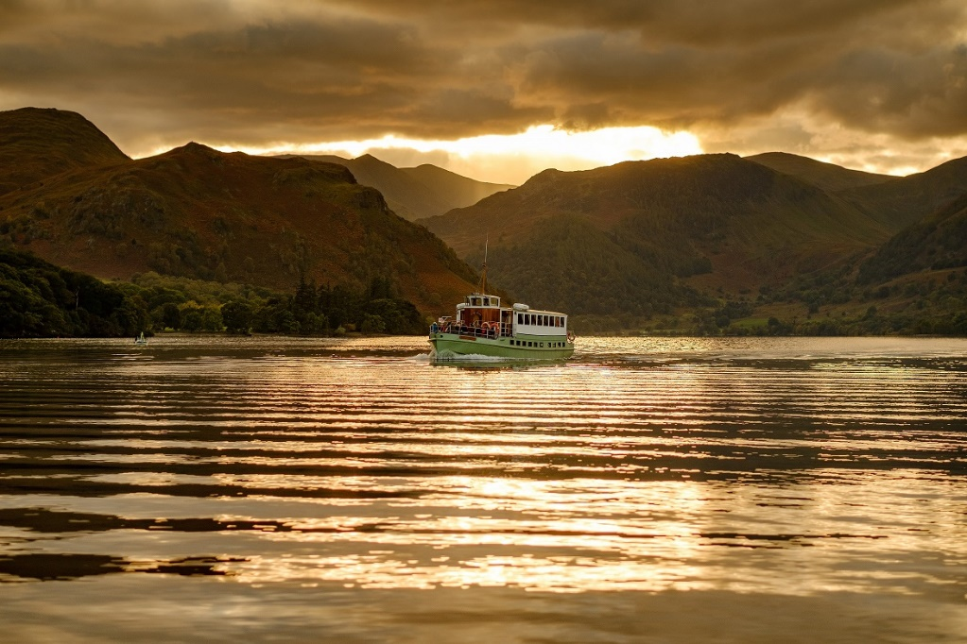
Ullswater ‘Steamers’ in-house photographer, Ben McGregor, says, “This is a unique opportunity to capture the stillness of Ullswater and its surrounding landscape and wildlife at a time of day most people don’t usually experience.”

Tickets are priced at £45 per person, which includes the cruise, parking at Glenridding and a complimentary tea/coffee and croissant on board.

Limited places are available at www.ullswater-steamers.co.uk or by calling 01768 482229. To get the most out of the session, people should familiarise themselves with their camera equipment in advance.

For anyone unable to take part in March, there is also a Dawn Photography Cruise planned to explore Ullswater’s autumn colours on Thursday 7 November 2024.

ENDS

Notes to Editors:

Hi-res image of Ullswater attached.

For further information and media enquiries, please contact: Heather Sewell, hsewell@cumbriatourism.org / 07795 487003.

Web: www.ullswater-steamers.co.uk
Facebook: www.facebook.com/ullswatersteamers
Twitter: @UllswaterSteam

